Tokeli jazz vocalist & bandleader

2010 Nomineed
“Jazz Artist of the Year”
Los Angeles Music Awards

2007 Nominee
“Jazz Album of the Year”
San Diego Music Awards
for “Where Do You Start?”

“Where Do You Start?”

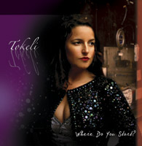
iTunes, CD Baby, Amazon
“That this is a debut release is almost too much to believe.” Acoustic Pie
“It’s her voice — in any language — that proves its greatest strength." Jazziz Magazine
“Complete mastery over such old and time-tested material … capable of expressing melancholy and joy with equal aplomb." INK19, United Kingdom
“Her voice brimming with sensuality and atmospheric beauty, Tokeli hits the spot. ... Magnificent!” Whisperinandhollerin.com, UK
“The album flexes the muscles of this impressive lineup of musicians,
and Tokeli is consistently in sync with them.” ALL ABOUT JAZZ

www.tokeli.com Booking: TVC Entertainment Agency www.tvcentertainmentagency.com
Artist Management, 619.519.1558

